Problem Statement

The Point class represents a point with x and y coordinates. Create a class Point according to the class diagram given below:

**Point:**

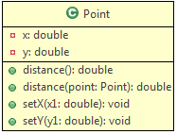

**Method Description:**  
  
**distance():**This method returns the distance of this point from origin.

**distance(Point point):** This method returns the distance of this point from the specified point.

Use the formula given below to implement the methods:



Hint: Use**Math.sqrt(double d)** method to calculate the square root, and **Math.round(double d)** method to round off the values.

**To do:** Make a Tester class and test the following functionalities:

* Create an object p1 of Point class
* Set the values of x and y
* display the distance of the point from the origin
* Create another object p2 of Point class
* Set the values of x and y
* Display the distance between p1 and p2

**Sample:**

**Input(for p1):**

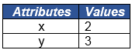

**Input(for p2):**



**Output:**

The distance of p1 from the origin is 3.6056

The distance of p1 from p2 is 4.2426